**MGT 201: Basics of Management**

**NIIT Technologies**

**Section: S4**

**Group number : 4**

**Name of the Group members:**

**1.Mihir Garg - U101114FCS195**

**2.Padegal Pranavi - U101114FCS224**

**3.Prateek Mishra - U101114FCS105**

**4.RM Rama Chidambaram - U101114FCS179**

**5.Rajat Singh - U101114FCS113**

**6.Rajat Sinha - U101114FCS114**

**1.Introduction :**

NIIT limited is an Indian multinational company which has started as an IT training center.It was founded by Rajendra Singh Pawar in 1981.

Seeing their customers trouble with difficult IT deployment issues,NIIT decided to explore the NIIT limited and try to help their customers to choose appropriate new technologies and also guide them in implementation of projects.

Thus NIIT limited created an IT software and services line of business to meet these demands of its customers by introducing an independent entity called NIIT Technologies in 2004 and it is 23.98 % of the NIIT ltd.

**2.Company profile:**

Name: NIIT TECHNOLOGIES.

Founded: 2004.

Founder: Rajendra S. Pawar, Vijay K. Thadani.

Headquarters: Noida, India.

Market: Globalized.

Industry: IT services, IT consulting

Type: Public.

Revenue: 2,682 crore

Services: IT, Business consulting and outsourcing services.

Business lines: Corporate Learning Group (CLG)

School Learning Group (SLG)

Skills and Careers Group (SNC)

Number of employees: 9,476 (as of 2016)

Chairman: Rajendra Singh Pawar.

Managing Director: Rajendra Singh Pawar.

Joint Managing Director: Arvind Thakur.

Non – Executive Director: Vijay k. Thadani.

Director: Anand Sudharshan.

CEO: Arvind Thakur.

CFO: Amit Kumar Garg.

CDO: Bhaskar Chavali.

# Non-Executive Independent Directors:

# Surendra Singh

Amit Sharma

Ashwani Puri

Holly.j Morris

# President and Global Business Head - Infrastructure Management Services:

Arvind Mehrotra

# President – Asia and Australia:

Deepak Khosla

# EVP & Head HR:

S.Viswanathan

# President US:

Lalit Dhingra

# Executive Vice President and Head of Europe:

Satya samal

# Executive Vice President and Head of BPO:

Siddhartha Singh

# Vision:

Be the first choice.

# Mission:

Enable Enterprises Manage Information Better.

# Objective:

Deliver Exceptional value and industry leading growth.

# Service Vision:

New Ideas, More values.

References:

1.<http://www.niit-tech.com/about-us/executive-leadership-team>

2.<http://www.niit-tech.com/about-us/board-directors>

3.<http://www.niit-tech.com/about-us/vision-and-mission>

4.Https://en.wikipedia.org/wiki/NIIT_Technologies

**3.Business model:**

**NIIT technologies key industry verticals includes:**

1. Banking and Financial services
2. Insurance
3. Travel and Transportation
4. Manufacturing and distribution’
5. Media.

T**hey offer their services in:**

1. Infrastructure Management
2. Application and development
3. Testing services
4. Robotic process
5. Business process
6. Geographical Information
7. Software products and also it includes some digital services like: 1.Digital Experience

2.Digital Analytic s

3.Digital Integration.

NIIT Technologies has grown rapidly from 2004-2008 by competing on its strength of specialization and also focusing on their key features of their industry segments.Even during the economic slow down in 2008-2012 years,they have come through the crisis strongly and even they had profits during that period of time.

Company’s main focus was on delivering their reliable products and services to their customers at a very low cost.But this is not going to help them in future as customers expectations has started changing and to meet their expectations they need to change their strategy.

Although NIIT technologies employees were very good and reliable, they were not able to think in an innovative which may lead them to failure and loss. So they implemented their idea of a fundamental culture shift which includes training of their employees according to their needs and making them think in an innovative way and also they conducted sessions for the senior level leaders by Edward De Bono in 2008 on lateral thinking and six thinking hats.They also conducted workshops and peer-peer sessions for creative problem solving.

They not only conducted the workshops but also they started giving rewards to their employees which will motivate them.

Later in 2012,when they had economic crisis,they came to know that: Now,they have to start telling customers what they can do rather than what customers want and the CEO of NIIT technologies said that as they are facing many challenges they can sustain only if they quickly adapt to the service vision and make the theme of “New Ideas,More Value”.He also believed that this will be the fundamental for the sustainable growth. So they started collaborating with the partners who will give more value to their business and overcome d their challenges.

**References:**

1.UYS_CASE_STUDY NIIT Technologies.pdf

**4.Timeline:**

As of 2016, the company has set itself some new targets, now the company wants to turn itself from an IT company into a firm that will focus on sectors such as e-commerce, banking retail, telecom and start-ups along with IT, though still IT is still a major point of focus for the company. NIIT Ltd. aims to be among with the top players in the IT Solutions department category, so it has started focusing more on digital services (An entirely automated service which is controlled by the customer of the service.) Currently the digital services area is a new focus for the company and it contributes to a mere 15% of the total revenues. Now the company’s main challenge in the near future is to increase its activity in this area and to make it grow. Another challenge that the company faces is how to make this facility(digital services)move forward for better/innovative functionality in the future?.

The customers here play an important role in eradicating this issue. Frequent engagements and regular feedback of the customers is needed in these new technologies so as to make it move forward.The company has already started by opening its cloud campuses for all and

# relocating about 60 skills and [career](http://economictimes.indiatimes.com/topic/career) centres that it had in South Africa and Mexico to India and [China](http://economictimes.indiatimes.com/topic/China), the two focus markets that it has identified for its skills and careers programmes.

**5.Organization structure and culture:**

**NIIT Organization Structure**

**PRESIDENT**:                      President

**CS-H / DH**:                           Consulting Services Head / Delivery Head

**S&M Head**:                         Sales & Marketing Head

**CSO:**                                    Commercial Services Organization

**SM:**                                      Sales Manager

**TSH**:                                     Technical Services Head

**MR:**                                      Management Representative

**TC**:                                        Technical Consultant

**TSE**:                                      Technical Service Executive

**BE**:                                        Business Executive

**CE**:                                       Commercial Executive

**PE**:                                        Production Executive

**EC**:                                        Education Consultant

**SA**:                                        System Analyst

**DS**:                                        Data Supervisor

**DO**:                                       Data Operator

**IA:**                                        Internal Auditor

**QR:**                                      Quality Reviewer

**QM**:                                     Quality Manager

**SCM:**                                   Software Configuration Manager

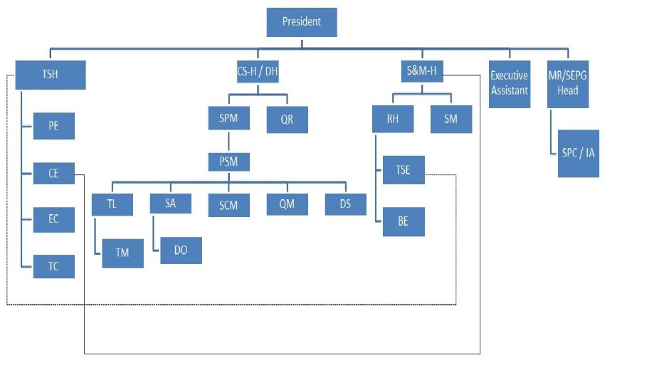

Fig 1.1 : Diagrammatic Representation of the Organization structure

**NIIT Culture**

At NIIT, an employee is not only a worker, but a "NIITian" – a part of the NIIT family. Pretty much as they focus on incredibleness in learning for their clients, they begin right here by building a culture of learning and coordinated effort in their own work environment.

In conjunction, their advantage and bolster bundles guarantee the physical and mental prosperity of each NIITian and his/her family. Benefits of being NIIT employee include:

**Health-care**

* Comprehensive health insurance.
* Prescription drug benefits and vision reimbursement program.
* Comprehensive dental insurance.
* Flexible Benefits Account, which allows for pre-tax contributions to a Health-care Account and/or Dependent Care Account.

**Insurance**

* Company-paid life and Accidental, Death and Dismemberment (AD&D) insurance coverage.
* Additional voluntary life and AD&D insurance coverage is available for employees and dependents at a discounted rate.
* Company-paid short- and long-term disability coverage. All coverage is effective immediately upon hire.

**Holidays and Vacation**

* 9 paid holidays per year, including 3 floating personal holidays.
* NIITians accrue 1.5 vacation days per complete calendar month worked, for a total of 18 vacation days for each full calendar year of employment.
* Employees accrue 6 additional vacation days upon completing 5 years of employment for a total of 23 days.
* Employees accrue an additional 5 days upon completing 10 years of employment for a total of 28 days.

**Other Benefits**

* Tax free Commuter Program benefits.
* Dependent Care.
* Employee Assistance Programs.
* Family Medical Leave.
* Health Club Facilities.

**References:**

1.<http://www.niit.com/en/learning-outsourcing/careers/Pages/working-at-niit.aspx>

2.https://iniitian.niit-tech.com/ntless/qmsesri/qm/Qm41.asp

**6.Challenges ahead**

In today’s economic world, the main challenge is the huge pressure to reduce the cost involved in the management of IT infrastructure. Since NIIT outsourced its IT infrastructure to other technology partners, they will have to implement Service Level Agreements to ensure high standards of IT service. Sooner the company will also have to adapt to changing customer IT infrastructure demands. For correct business decisions and plans NIIT has been generating monthly reports to understand the performance of the current IT infrastructure. They should focus on customer satisfaction and customers should be regularly surveyed in order to understand the company’s IT infrastructure requirements.

They should also focus on choosing a good business model for getting maximum profit and better returns from investment. They should focus on the cost of managing applications and adjust service levels based on their utility.

Customers demand bigger and better quality of service at lower costs. To cater to the growing demands, NIIT requires a scalable IT infrastructure in order to keep customers satisfied and stay ahead of the competition. Emerging technologies such as cloud computing and mobility rapidly change the business landscape. NIIT has to be in-sync with these technologies in order to provide desired benefits to the customers. Immediate adoption of the technologies will lower the overall cost and will increase revenues of the companies. Tackling the challenges will also help them to align their infrastructure with the business goals and transform it into a more business aligned unit. Enterprises seeking competitive advantage must provide easy access to reports, dashboards, tools and other systems to ensure visibility the infrastructure management services. Near-real time information will help in delivering excellent service to the customers and will provide users with the flexibility to work from anywhere, anytime.

NIIT ltd as well as NIIT technologies non executive director mentioned that to boost the revenue,they are going to focus on the non-linear business services as the 60% of its revenue is from those services but competition is more in that services.

**References:**

1.UYS_case study NIIT Technologies.pdf

**7.Industry and competitive scenario:**

In the coming days, the company plans to focus especially on startups and retraining mid-tier IT professionals. NIIT is looking at launching new short and intense programs around SMAC (Social, Mobile, Analytic and Cloud). NIIT plans to launch training.com to offer online training. IAMAI recognizes NIIT as the “Best Educational Website”. NIIT appoints Barry Libert, renowned Digital Board Member & Author, as a Digital Adviser to the NIIT Board. NIITentered into an exclusive partnership with US based Open Matters, LLC led by Barry Libert, renowned Digital Transformation Board Adviser. This initiative will enable the top leadership of top tier firms to become digital leaderswho will drive digital transformation initiatives that lead to greater growth and value.

The company recently acquired the business of Bangalore-based start-up **Perceptron** Learning Solutions. The strategic acquisition brings together complementary technology platforms and capabilities of NIIT and Perceptron, enabling NIIT to further accelerate its Digital Transformation initiatives – StackRoute, digiNxt, NIIT.tv and Training.com. Private Limited NIIT enters MoU with Guian New Area, China. NIIT's current digital transformation training portfolio of StackRoute and DigiNxt focus on **Digital Innovator** training and **Digital Developer** training respectively. During the quarter NIIT unveiled **[www.training.com](http://www.training.com/)** multi-modal learning platform, a direct-to-device initiative for advanced career programs. To commemorate the occasion a first-of-its-kind program, "Post Graduate Certificate in General Management" (PGCGM) was announced on [www.training.com](http://www.training.com/), to be offered in association with **Indian Institute of Management, Calcutta** (IIM-C).

NIIT announces a 10% record EBITDA margin for the first time in 4 years, on a growth of 10%, according to its latest Q2 report for July- Sept 2016. The report also mentioned revenue of Rs. 298.4 cr which has gone up by 10% YoY. Also its Operational PAT has increased by 43% YoY and net debt down by 30% QoQ. The company’s revenue s fuelled by 23% YoY growth in Corporate Learning Group and an EBITDA of 9% in Skills and Careers group. NIIT's competitors include InfoPro Learning, Inc., LIQVID eLearning Services Pvt., Ltd., Manipal Global Education Services, Zee Learn, Aptech and MT Educare. NIIT and its competitors have an average revenue of $79.8M. NIIT has the highest revenue with $150M. That is 42% above its competitors' average. Networth of NIIT as of Mar’16 is 811.71cr as compared to 250.75cr of Zee Learn which is closest to NIIT among all competitors while Total Assets are of worth 986.31cr, 2.5 times of that of Zee Learn whose Total Assets stand at 377cr.

**References:**

1. moneycontrol.com
2. Owler.com
3. Wikepedia.com

**8.Our Advice to the company:**

As NIIT technologies has their clients in USA and other European countries, culture differs from one place to other. In USA, everyone speaks English. So employees from India also can do the services but the situation is not same in all European countries.so the communication between the clients and the Employees may be affected.without proper communication, nothing is possible.So it will be better if they start teaching the European languages to their employees and also to give preference to the candidates who know the foreign languages while recruiting.

They try for the best innovation which is good but there are chances of failure if it does not work. But the best thing about the company is they never back-out from the failures and also director of the company said that “ We learn more things from failures than success” and so they do not think failure as a threat.

NIIT’s cost structure cannot be weak as it means that its costs are high in comparison to their competitors. NIIT can be updated with more new technologies to meet their customer’s need with new and improved product and services. Even though NIIT is one of the best franchises, they should give more focus on benefits of NIIT franchises in India in order to make profit in long run. They should treat their own centers and the franchisee centers equally well. Also they can expand their streams of learning.

**References:**

1. <http://www.niit-tech.com/>
2. <https://en.wikipedia.org/wiki/NIIT_Technologies>
3. https://wikihealth.com/